**QUIZ Ⅳ**

**Biochemistry Ⅱ January 5, 2015**

**Name:____________ ID(学号):_____________**

**Ⅰ. Multiple choice questions (选择题):**

1. The Michelson-Stahl expeiriment, in which replicating DNA was labeled with heavy nitrogen(15N) and light nitrogen(14N), proved that
2. DNA is synthesized in a 5’ to 3’ direction.
3. DNA strands separate during DNA replication.
4. DNA replication is semidiscontinuous.
5. DNA replication is bidirectional.

**Answer_____________**

1. Which of the following is a function of the DNA polymerase Ⅲ of *E.coli*?
2. It synthesizes the primers needed to initiate DNA synthesis.
3. It synthesizes only the lagging strand.
4. It removes RNA primers during replication.
5. It synthesizes only the leading strand.
6. It is the principle replication enzyme.

**Answer_____________**

1. A mature mRNA could become much longer than its precursor pre-mRNA through
2. 5’-end capping.
3. Splicing.
4. 3’-end cleavage.
5. Polyadenylation.

**Answer_____________**

1. Assuming the 5’🡪3’connection of writing nucleotide sequence, indicate which of the following mRNA codons can be recognized by the tRNA anticodon ICG.***(With more than one correct answers)***
2. CGA
3. CGG
4. AGC
5. CGU
6. CGC
7. UGC
8. GGC

**Answer_____________**

**Ⅱ.Comprehensive questions （综合题）:**

The sequence of the template DNA strand is 5’-ATATCCATTAGTGAC-3’

1. What is the sequence of the mRNA produced?
2. What amino acid sequence could be coded by the mRNA starting from the 5’ end? You will get extra points if you also write the sequence using the one-letter code.
3. What amino acid sequence could be coded if the underlined C is mutated to A? 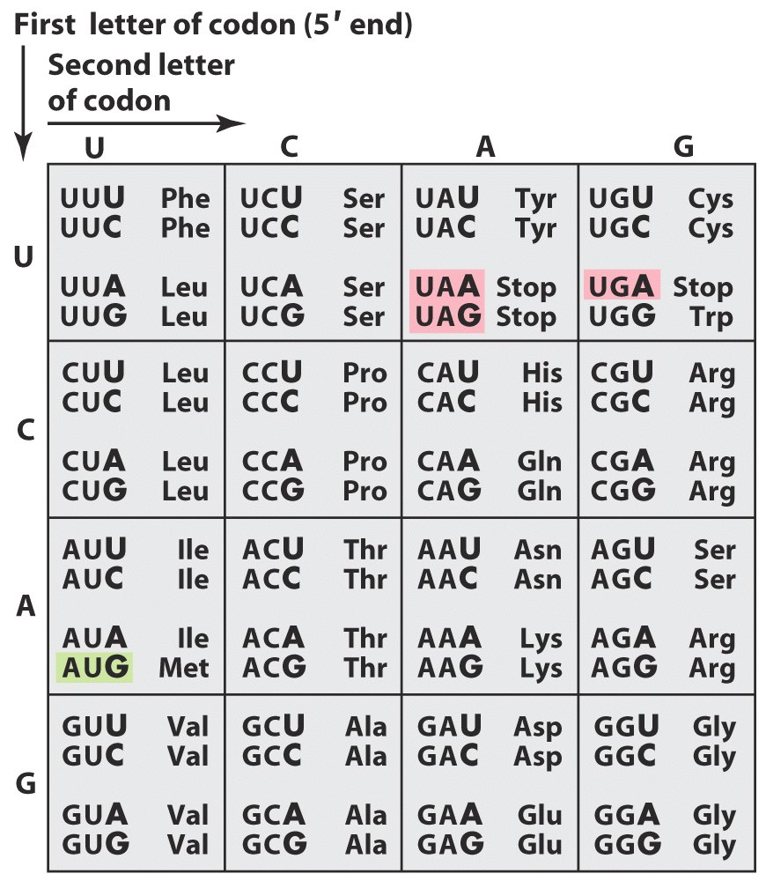

Answer for QUIZ Ⅳ(January 5, 2015):

Ⅰ. Multiple choice questions (选择题):

1. B
2. E
3. D
4. ADE

Ⅱ. Comprehensive question （综合题）:

1. 5’-UAUAGGUAAUCACUG-3’
2. Val-Thr-Asn-Gly-Tyr(VTNGY)
3. Val-Thr-Asn(VTN)

**QUIZ Ⅳ**

**Biochemistry Ⅱ January 6, 2015**

**Name:____________ ID(学号):_____________**

**Ⅰ. Multiple choice questions (选择题):**

1. If a completely double-stranded DNA molecule undergoes two rounds of replication in a solution free of radioactive label, what is the radioactivity status of the resulting four double-stranded DNA molecules?
2. Half should contain radioactivity in both strands
3. None should contain no radioactivity
4. All should contain radioactivity in both strands
5. One should contain radioactivity in both strands
6. Half should contain no radioactivity

**Answer_____________**

1. Which of the following is a function of the DNA polymerase Ⅰ of *E.coli*?
2. It is the principle replication enzyme.
3. It synthesizes the primers needed to initiate DNA synthesis.
4. It synthesizes only the lagging strand.
5. It removes RNA primers during replication
6. It synthesizes only the leading strand

**Answer_____________**

1. What is the role of the Shine-Dalgarno sequence?
2. It marks the polypeptide for translocation into the lumen of ER.
3. It targets proteins for degradation
4. It guides the 30S ribosome to the initiating (5’) AUG of the mRNA.
5. It acts as a signal for termination of translation.

**Answer_____________**

1. Assuming the 5’🡪3’connection of writing nucleotide sequence, indicate which of the following anticodons can recognize codon CCU.***(With more than one correct answers)***
2. GGG
3. CGG
4. AGG
5. GGC
6. GGA
7. IGG
8. GGI

**Answer_____________**

**Ⅱ.Comprehensive questions （综合题）:**

Consider the mRNA sequence: (5’)-AAUGCAGAGUUAUAC-(3’)

1. What is the sequence of the coding strand of DNA?
2. What amino acid sequence could be coded by the mRNA starting from the 5’ end? You will get extra points if you also write the sequence using the one-letter code.
3. What amino acid sequence could be coded if the underlined U is mutated to G? 

Answer for QUIZ Ⅳ(January 6, 2015):

Ⅰ. Multiple choice questions (选择题):

1. E
2. D
3. C
4. ACF

Ⅱ. Comprehensive question （综合题）:

1. (5’)AATGCAGAGTTATAC(3’)
2. Asn-Ala-Glu-Leu-Tyr(NAELY)
3. Asn-Ala-Glu